**Instructions:**

1. **Create a folder in C directory as instructed below:**
   * + 1. **Folder name: YourDivision_last-three-digit-Enrollmentno**

**Eg: Your Division : A**

**Enrollment no: 001**

**Folder name: A_001**

1. **The application/project name must be same as your folder name.**
2. **Don’t save your application in *source/repos. Save your application in your folder (created in Step 1)***
3. **Have frequent backup of your work.**

Connection string: 10.25.50.252/Wad.pdf

Manual : 10.25.50.252/asp_manual.pdf

**You’re tasked with developing a user-friendly *Electronics Management System* for efficient inventory control and smooth order processing. The system should help admins manage inventory and allow users to easily browse, order, and track electronic devices.**

**Functionalities to be covered in the system:**

|  |  |
| --- | --- |
| **Admin** | **User (Customer)** |
| **Electronics Management:**   * Adding/ Update/ Remove electronic devices | **Browsing Electronics Catalog:**   * Searching and viewing available electronic devices. |
| **Order Management:**   * Viewing orders placed by users. * Updating order statuses | **Placing Orders:**   * Selecting electronic devices and placing orders. |
| **Viewing Order Status:**   * Checking the status of their orders |

**Modules:**

**Structure the Modules (Web pages) web pages for an Electronics Management System based on the distilled functionalities for admins and users:**

|  |  |
| --- | --- |
| **Admin** | **User (Customer)** |
| **Login Page**. | **Login Page.** |
| **Admin Dashboard/Home Page:**   * Overview of orders and electronics management functionalities. | **User Dashboard/Home Page:**   * Provides a summary of placed orders and order status tracking. |
| **Electronics Management Pages:**   * **Electronics List Page**: Displays the list of electronic devices with options for add/edit/delete. * **Add/Edit Electronics Page:** Add new electronics or modify existing details | **Electronics Catalog Page:**   * **Browse Electronics Page:** Allows users to search and view available electronics. |
| **Order Management Page:**   * **Orders Page**: Shows orders placed by users with options to update order statuses. | **Order Placement and Status Page:**   * **Place Order Page**: Enables users to select electronics and place orders. * **Order Status Page**: Displays the status of the user's placed orders. |

**Assignment 1 Date:**

|  |
| --- |
| **Aim:**  To acquaint students with the **Visual Studio interface, various input controls &**  **handling page post backs.**  **Task:**  Design the layout for the management electronic devices, considering the following fields  and input controls |

***USE PROPER NAMING CONVENTIONS FOR INPUT CONTROLS***

**USE PROPER NAMING CONVENTIONS FOR INPUT CONTROLS**

**● Type** (Dropdown, Options: Mobile, Laptop, Tablet)

**● Brand** (Dropdown, dynamic binding – data must appear on “type” selection)

**● Model** (textbox)

**● Description (**textbox multiline mode)

**● Price** (textbox, Number mode)

**● Quantity (**textbox, Number mode)

**● Colors** (Radio button, **options**: blue, black, gold, rose gold)

**● Accessories** (Checkbox **options:** Charger, Headphones, Touch pen, Wireless mouse)

**● Submit - On submit, display all the inputted details in a single label (check figure)**

**● Reset -clear controls**

**REMOVE TABLE BORDER ONCE FORM IS DESIGNED**

**USE PICTURE FOR REFERENCE ONLY**

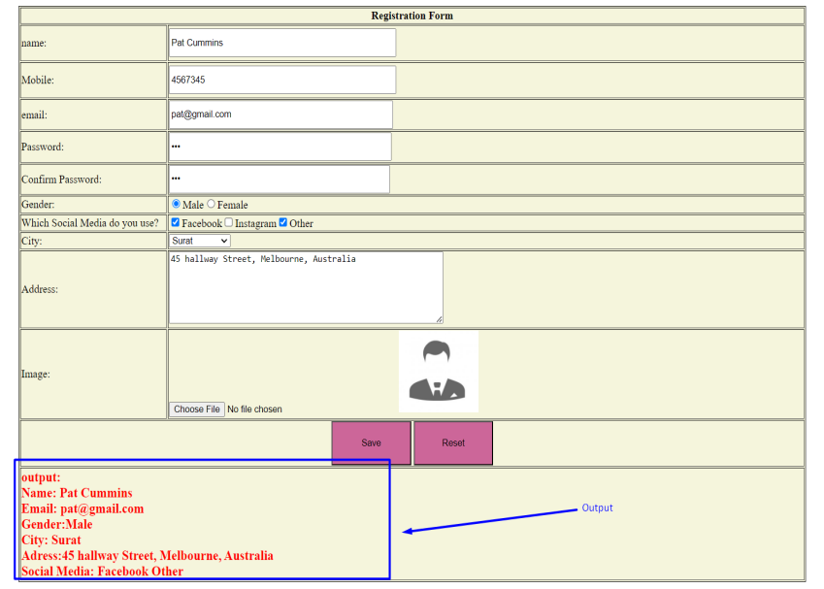

**Assignment 2 Date:**

|  |
| --- |
| **Aim:** Develop an understanding of working with **databases & handling exceptions.**  **Task:** Concerning ***assignment 1,*** *perform CRUD operations on* ***tblDevice*** |

**Q1) Create a database *dbElectronics* consisting of tables schema as given below**

**Relationships:**

**Electronics to Orders:** One-to-Many relationship (one electronic device can be part of multiple orders).

**Users to Orders:** One-to-Many relationship (one user can place multiple orders).

|  |
| --- |
| **tblBrand:** b_id (PK), BrandName (Dell, iPhone, Lenovo, Samsung)  type (e.g., Mobile, Laptop, Tablet)  **Add two records of Brand for each type** |
| **tblDevice:** d_id (PK),b_id (FK), model, description, Price, quantity,  color,accessories |
| **tblCustomer:** Name, Email (PK), Phone, Address, Password, City |

**ADMIN SIDE**

**Basic:**

Use **Try-Catch-Finally** to handle exception or errors during the execution of upcoming operations.

Q1) Establish Connection with database **dbElectronics** using ***Web.Config.***

Q2) Enter data manually in the **tblBrand, and tblDevice.**

Q3) **VIEW:** Display data inserted in tblDevice in **GRIDVIEW.**  Display “BrandName” in place of

b_id.

**Moderate:**

Q4) Display all the brands from the database in the **‘Brand’** dropdown created in ***assignment 1,***

to allow user to select brand. ***Brands must be displayed type wise.***

**Q5) For INSERT operation:**

1. Save device details in the **tblDevice.**

**Q6) For UPDATE operation: *(Update on button Click event)***

1. Select a row from the grid view using AutoGenerateSelectButton="True". On selection, all the values of the selected row must be set in the controls. Set Id in a global variable. ***Use d_id to update a record***

**Q7) DELETE selected data*. ( Set Gridview property AutoGenerateDeleteButton="True", and write code on Gridview RowDeleting event)***

**Advance:**

**Implement search functionality:**

1. Allow admin to select a brand from the dropdown, and ***display data in Grid view accordingly***.

**Assignment 3 Date:**

**Aim:** Introduction to Validation Controls

**Task:** Concerning assignment 1 & 2, apply suitable validation controls to the input controls.

***Key to add in web.config.***

<appSettings>

<add key="ValidationSettings:UnobtrusiveValidationMode" value="None" />

</appSettings>

**Create a new table, named “tblCustomer” with the following fields :**

**tblCustomer:** Name, Email (PK), Phone, Address, Password, City (Dropdown )

1. Design an interface for registering customers.
2. Add at least 5 customer details in tblCustomer.

**ADMIN SIDE**

***It's an essential step to ensure that only reliable and expected data is accepted and processed, Hence, before a data is added or modified, validate it***

***In device management page created in assignment 1, apply following validation:***

* + - 1. Apply regular field validation controls to validate empty input controls.
      2. Use ***InititalValue*** property to validate city and state value.
      3. Apply compare validator ***on price and quantity.*** Make sure, the value entered is greater than 0. ***Use, ValueToCompare and operator property.***

**CLIENT SIDE**

***Apply following validation in customer registration page:***

Apply a regular expression to validate the email and Phone ***Expression for Phone: [0-9]{10}***

Use **compares validator** control to compare passwords and confirm passwords

**Assignment 4: Date:**

**Aim:** Getting Acquainted with the concepts of concepts of sessions, requests, responses, and

page redirection.

**Task:** 1) Authorizing and authenticating admin credentials.

2) Redirecting pages

Q1) Design a login page for customer access that verifies credentials from the table,

**tblCustomer.**

Q2) Apply suitable validation controls on Login Page.

Q3) Write a code snippet script to validate the customer's login credentials. Upon successful

Authentication, store customer’s Email in a session and redirect the customer to a Home

page.

Q4) Further, the customer’s email must be displayed on the top right corner of the page.